**Virulence Data Information**

The file pickles_and_pngs.tar.gz contains the following:

**Genera: Campylobacter, Escherichia, Listeria, Salmonella, Shigella**

**domain** - contains pickle and png files from the analysis of pivot domain architecture vs neighbor domain architecture

**genome** - contains pickle and png files from the analysis of genome vs domain architecture

**ClusterMapData.py** - Python class file that needs to be imported in order to create the deserialized version of the pickled object.

**requirements.txt** - dependencies

**pickle_test.py** - a small python program that loads each pickle and constructs a ClusterMapData instance and outputs some info about it.

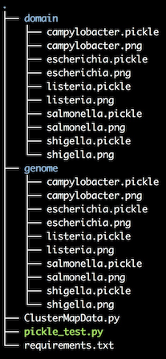

IBM collaborators used a python 3.7 virtual environment. To create run:

* python -m venv venv
* . ./venv/bin/activate
* pip install -r requirements.txt
* ./pickle_test.py

Reference data such as domain architectures, protein names, virulence data, etc. can be found in the **csv_files.tar.gz** file. This file contains the following:

**domain_architecture.csv** - maps unique IPR sets to a common UID key.

* Headers:
  + DOMAIN_ARCHITECTURE_UID_KEY
  + DOMAIN_ARCHITECTURE

**ipr.csv** - provides name, description and type for each IPR accession in domain_architecture.csv

* Headers:
  + IPR_ACCESSION
  + NAME
  + DESCRIPTION
  + TYPE

**protein_domain.csv** - cross reference between protein and domain architecture.

* Headers:
  + PROTEIN_UID_KEY
  + DOMAIN_ARCHITECTURE_UID_KEY

**protein_name.csv** - maps OMXWare protein full names to UID key.

* Headers:
  + PROTEIN_UID_KEY
  + PROTEIN_FULLNAME

**protein_virulence.csv** - maps VFDB (<http://www.mgc.ac.cn/VFs/main.htm>) reference to PROTEIN_UID_KEY

* Headers:
  + PROTEIN_UID_KEY,
  + SHORT_NAME
  + FULL_NAME
  + VIRULENCE_FACTOR
  + GENUS
  + SPECIES
  + STRAIN